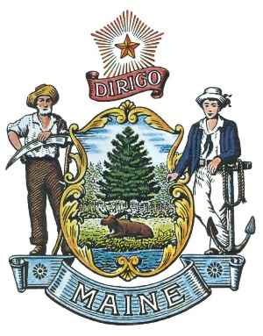

State of Maine LOSAP
LOSAP Board of Directors Meeting Minutes
March 15, 2023

Attendees: Bill Gillespie, Stephan Bunker, Jeff Brackett, Fred Brewer, Kevin Curry

Guests: None

The Zoom meeting was opened by Chair Bill Gillespie at 12:00

Discussion on Corebridge and implementation of the program for the administration of the program.
We have been meeting with them every week to get the program implemented. We are now able to accept contributions from municipalities.

LD 588 discussion and pending testimony in Criminal Justice on Monday March 20, 2023.
We have bi-partisan support for the program. Chip Curry is sponsor with the bill and plans to testify on Monday.

Motion to adjourn at 12:12 by Fred Brewer, Bill Gillespie Seconded, all in Favor.
Respectively Submitted
Frederick Brewer

