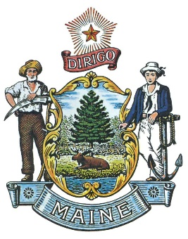
State of Maine LOSAP
LOSAP Board of Directors Meeting Minutes
February 11, 2019

Attendees: Bill Gillespie, Fred Brewer, Stephan Bunker, Jeff Brackett and Bill Hussey

Guests: Duane Bickford and Marshall King (Unappointed Board Members) Dan Brooks
Chad Lewis, Division of Procurement Services
Bruce Linger (Lincoln Financial) Jonathan Paris (NE Region rep for Lincoln Financial)
Tom Green (Green Insurance Service)
Ed Holohan via phone.

The meeting was called to order by Bill Gillespie at 10:01

RFP Discussion – Discussion on LR 308 for funding for the program but we don’t currently have an LD at the moment. Funding is requested for $2.6m to fund the program. Ed – Investment administration plan was covered under the current RFP. Lincoln handles 400 LOSAP plans nationwide. Bruce L brought up the administration of the program was covered well by the RFP. The shortcoming was the integration of the Third-Party Administrator (TPA) into the RFP. Discussion on the service credit calculation and how firefighters earn credit. Ed brought up how the EMS calls can skew the allocation of contributions. Bruce L discussed the integration of a 403b if we want to have an employee contribution to the program. Bruce L suggested rebidding the RFP and separating the Administrative model and LOSAP investment model pieces out.
Bruce Linger, Jonathan Paris and Tom Green (Ed Holohan phone call was ended) all left the meeting at 10:55.

Continued discussion with Chad Lewis about the RFP
Economic impact statement should be removed because of the current administration. Stephan brought up the purchasing rules that govern our board. Timeline will be compressed with the goal of April 1 approval of both service providers. March 1 for submission to Purchasing then the 7th for Questions and 14th for the answers and 2 weeks to get RFP’s submitted.

Chad Lewis left the meeting at 11:33

Discussion on Secretary position. Bill H. Trying to convince his wife to take the position.

Minutes: Stephan Bunker motion to approve Jeff Brackett seconded. All approved.

Bill G. will work on the two board appointments that are pending.

LR 308 is currently being reviewed. The final wording is being drawn up at this point and we will have to work on testimony to ask for the $2.6m funding.

Website – Working with Informe to develop the website. We have received word from OIT and our URL has been approved. The website copy has been submitted to Katie and Informe can start working on the website. The goal is to have it operational in about a month.

Legislative breakfast is the 14^{th at} 7:00 (till 9:30) need to be well attended with dress uniform. Touch base with your local legislators to let them know you are attending to get them involved.

Facebook page currently has 433 likes.

Next meeting is March 11^{th at MMA}.
Stephen Bunker Motion to adjourn at 11:53, Bill Gillespie Seconded, all in Favor.

Respectively Submitted
Frederick Brewer

Future Meetings April 8th, May 13th and June 10th

